Software Requirements Specification for E-Mart BD
Resoft Technology
Daffodil Smart City
Birulia, Savar, Dhaka-1216

Mahmudul Hasan
Founder
E-Mart BD
Mirpur-10
Dhaka, Bangladesh

Dear Mahmudul Hasan,

Re: Enclosed Application Agreement for E-Mart BD.

At Resoft Technology, we are aware that creating client-oriented Application takes a mixture of technical excellence and clear communication and our firm hires only the best to ensure you receive both. We know that every client is unique, and we strive to deliver an individual, innovative, and affordable proposal every time and to follow it through with an outstanding delivery which is both on time and within budget.

According to your business requirement we design E-commerce Mobile Application System for you, in this agreement paper we right each part and all possible feature which covered our application. So please read carefully and if it satisfies you then sign and confirm the agreement.

Yours Truly,

Project Manager
Mehedi Hasan
Resoft Technology
Table of Contents
Table of Contents ii
1. Introduction 1
1.1 Purpose 1
1.2 Document Conventions 1
1.3 Intended Audience and Reading Suggestions 1
1.4 Project Scope 2
1.5 References 2
2. Overall Description 2
2.1 Product Perspective 2
2.2 Product Features 3
2.3 User Classes and Characteristics 3
2.4 Operating Environment 3
2.5 Design and Implementation Constraints 3
2.6 User Documentation 4
2.7 Assumptions and Dependencies 4
3. System Features 5
4. External Interface Requirements 5
4.1 User Interfaces 5
4.2 Hardware Interfaces 7
4.3 Software Interfaces 7
4.4 Communications Interfaces 8
5. Other Nonfunctional Requirements 8
5.1 Performance Requirements 8
5.2 Safety Requirements 8
5.3 Security Requirements 8
5.4 Software Quality Attributes 8
6. Other Requirements 9
Appendix A: Glossary 9
7. Contact us…………………………………………….……………………………………...10

Introduction

Purpose
E-Mart BD is the mobile application is intent to provide complete solutions for vendors as well as customers through a single gateway using the internet as the sole medium. It will enable vendors to set up online grocery shops (daily needs products), customers to browse through the shop and purchase them online without having to visit the shop physically. The administration module will enable a system administrator to approve and reject requests for new shops and maintain various lists of shop of categories.

Document Conventions:
- Entire document should be justified.
- Convention for main title:
- Font Face: Times New Roman
- Font Style: Bold
- Font Size: 32
- Convention for subtitle:
- Font Face: Time new Roman
- Font Style: Bold
- Font Size: 32
- Convention for body
- Font Face: Times New Roman
- Font Style: Bold
- Font Size: 32

Intended Audience and Reading Suggestions
- Customers
- Authority
- Developers
- All Users

Project Scope
- Secure registration and profile management facilities for Customers.
- Adequate searching mechanisms for easy and quick access to products and services.
- Creating a Shopping cart so that customers can shop ‘n’ no. of items and checkout finally with the entire shopping carts. Customers can add or delete items in the cart.
- Regular updates to registered customers of the OFS about new arrivals.
- Uploading ‘Most Purchased’ Items in each category of products in the Shop.
- Strategic data and graphs for Administrators and Shop owners about the items that are popular in each category and age group.
- Maintaining database of regular customers of different needs.
- Shop employees are responsible for internal affairs like processing orders, assure homedelivery, getting customer's delivery-time feedback, updating order's status, and answering client’s queries online.
- Feedback mechanism, so that customers can give feedback for the product or service which they have purchased. Also, facility rating of individual products by relevant customers.
- Adequate payment mechanism and gateway for all popular credit cards, cheques, and other relevant payment options, as available from time to time.

References
- JAVA: - https://www.javatpoint.com/java-tutorial
- XML: - https://www.tutorialspoint.com/xml/index.htm
- PHP: - https://www.w3schools.com/php/DEFAULT.asp
- Firebase: - https://www.tutorialspoint.com/firebase/index.htm

Overall Description

Product Perspective
E-Mart BD is aimed towards the vendors who want to reach out to the maximum cross-section of customer and common people who can be potential customer. This project envisages bridging the gap between the seller, the retailer, and the customer. OFS should be user-friendly, ‘quick to learn ‘and reliable software for the above purpose. OFS is intended to be a stand-alone product and should not depend on the availability of other software. It should run on
Android based platform.

Product Functions:
- The main purpose of this project is to reduce the manual work.
- Functions: A Customer can browse through the shops and choose products to place in a virtual shopping cart. The shopping cart details can be viewed, and items can be removed from the cart. To proceed with the purchase, the customer is prompted to login. Also, the customer can modify personal profile information (such as phone number and shipping address) stored by the application. The customer can also view the status of any previous orders and cancel any order that has not been shipped yet.

User Classes and Characteristics:
- The user should be familiar with the shopping mall related terminology like Shopping cart/Checking out/Transaction etc.
- The user should be familiar with the Internet.

Operating Environment
- The product will be operating in android Mobile Environment. E-Mart BD shop system is a mobile application and shall operate in all android mobile up to API level 24. The only requirement to use this online product would be the internet connection.

Design and Implementation Constraints
- An online store is a virtual store on the Internet where customers can browse the catalog and select products of interest. The selected items may be collected in a shopping cart. At checkout time, the items in the shopping cart will be presented as an order. At that time, more information will be needed to complete the transaction. Usually, the customer will be asked to fill or select a billing address, a shipping address, a shipping option, and payment information such as credit card number. An e-mail notification is sent to the customer as soon as the order is placed.

User Documentation
The product will include user manual. The user manual will include product overview, complete configuration of the used software (such as Firebase), technical details, backup procedure and contact information which will include email address. There will be no online help for the product at this moment. The product will be compatible with the API 24 or higher. The databases will be created in the firebase database.

Assumptions and Dependencies

The assumptions:
- The coding should be error free.
- The system should be user friendly so that it is easy to use for the users.
- The system should have more capacity and provide fast access to the database.
- The system should provide search facility and support quick transactions.
- The E-Mart BD shop system is running twenty-four hours a day.
- Users may access from any computer that has internet browsing capabilities and an internet connection.
- user must have their correct usernames and passwords to enter their online accounts and do actions.

The dependencies:
- The specific hardware and software due to which the product will be run.
- Based on listing requirements and specification the project will be develop and run.
- The end users (admin) should have proper understanding to the product.
- The system should have the general report store.
- The information of all users must be stored in a database that is accessible by the E-Mart BD system.

System Features
- The website authority should ensure the customer provide real product.
- Customer support is available from the authority.
- Customer information security confirm.
- Manage customer information.
- To increase efficiency of managing the authority work.

External Interface Requirements

User Interfaces
Admin can View, Edit and Delete everything on the product.
User can view the whole information.
 | 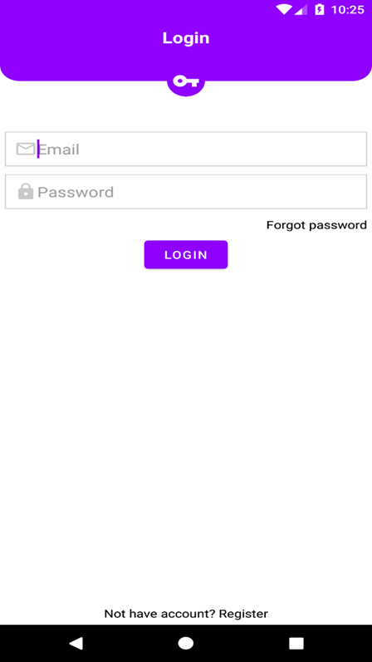

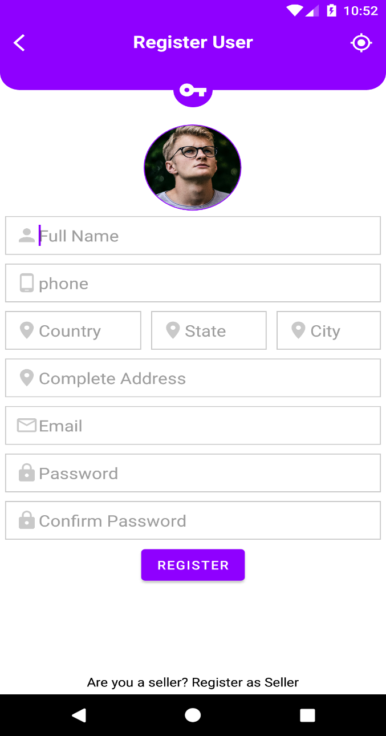 | 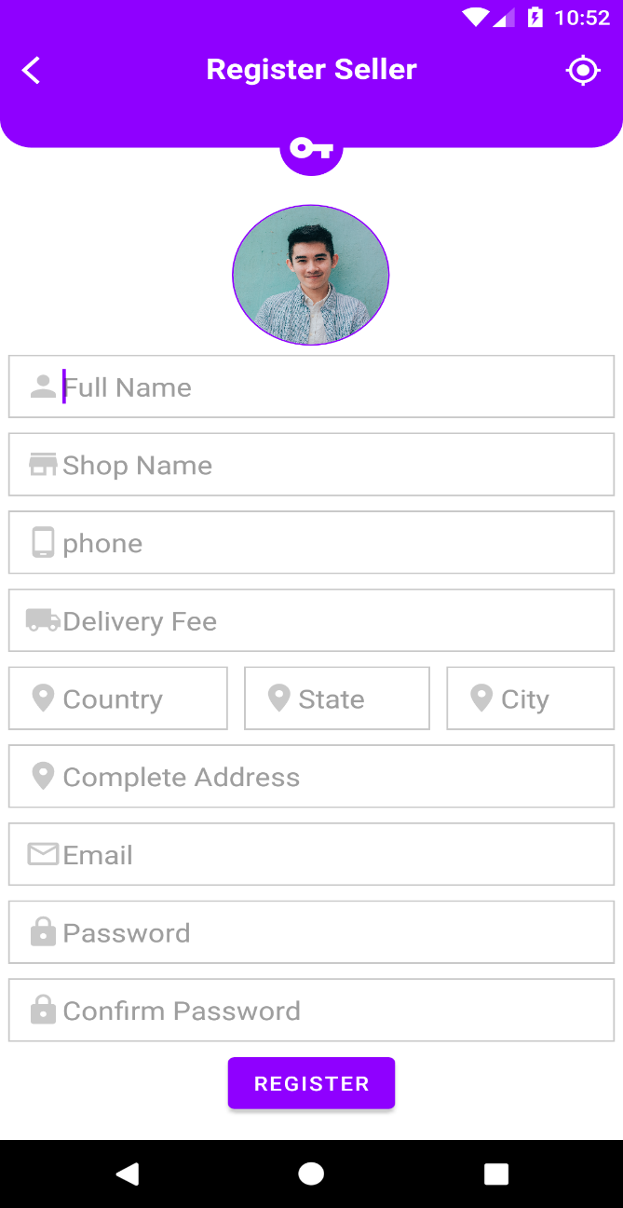

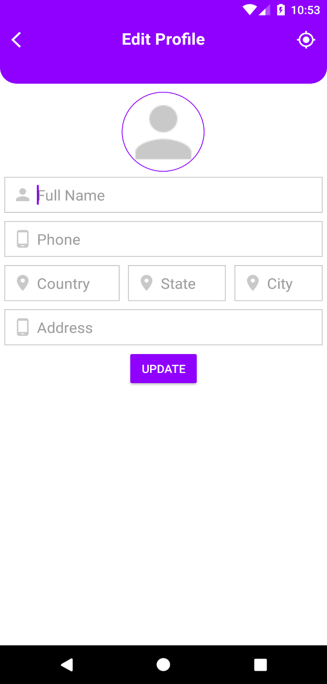 | 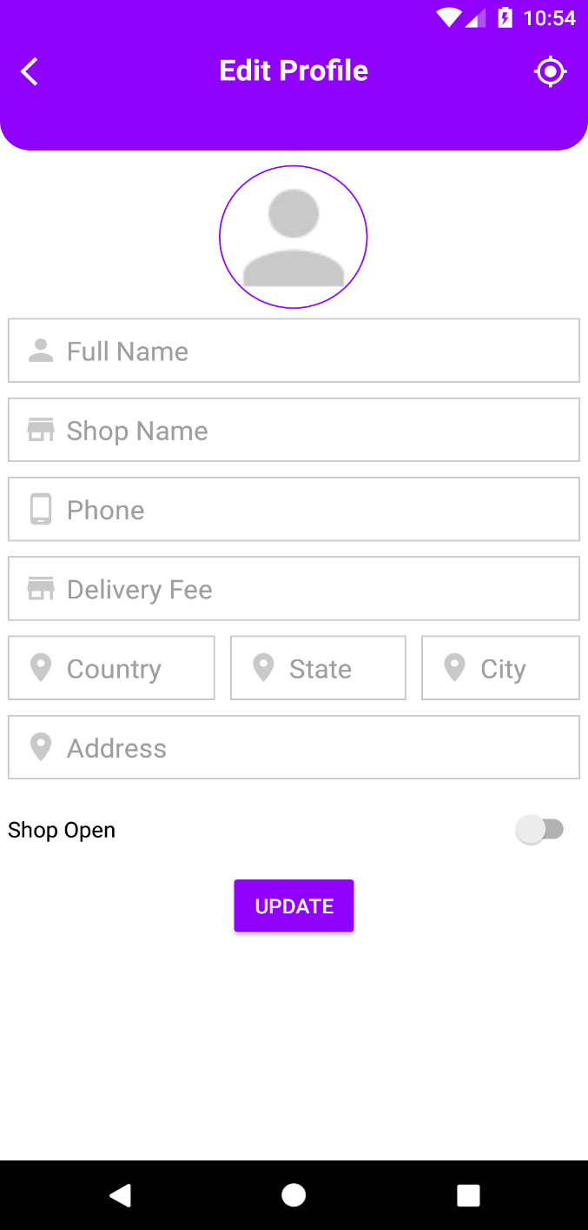

Hardware Interfaces
- Operating System: Android
- RAM: 512 MB
- Storage: 2GB

Software Interfaces
- Android Studio
- Firebase
- Figma

Communications Interfaces
The Customer must connect to the Internet to access the Application:
- Dialup Modem of 52 kbps.
- Broadband Internet.
- Dialup or Broadband Connection with an Internet Provider.

Other Nonfunctional Requirements

Performance Requirements
There is no performance requirement in this system because the server request and response are depended on the end user internet connection.

Safety Requirements
The database may get crushed at any certain time due to virus or operating system failure. There for it is required to take the database backup so that the database is not lost. Proper UPS/ Inverter facility should be there in case of power supply failure.

Security Requirements
- System will use secured database.
- Normal users can just read information, but they cannot edit or modify anything except their personal and some other information.
- System will have several types of users and every user has access constraints.

Software Quality Attributes
- There may be multiple admin’s creating the project, all of them will have the right to create changes to the system. But the members or other users cannot do changes.
- The project should be open source.
- The quality of the database is maintained in such a way so that it can be very user friendly to all the users of the database.
- The user be able to easily download and install the system.

Other Requirements
E-Mart BD shall manage expected and non-expected errors in ways that prevent loss in information and long downtime period.
Appendix A: Glossary
The following are the list of conventions and acronyms used in this document and the project as well:
- User: Normally user can comment or view details of E-Mart BD availability.
- Client: Intended users for the software.
- SQL: Structured Query Language; used to retrieve information from a database.
- SQL Server: A server used to store data in an organized format.
- Layer: Represents a section of the project.
- User Interface Layer: The section of the assignment referring to what the user interacts with directly.
- Application Logic Layer: The section of the assignment referring to the web server. This is where all computations are completed.
- Data Storage Level: The section of the assignment referring to where all data is recorded.
- Use Case: A broad level diagram of the project showing a basic overview.
- Class diagram: It is a type of static structure diagram that describes the structure of a system by showing the system’s cases, their attributes, and the relationships between the classes.
- Interface: Something used to communicate across different mediums. Unique Key: Used to differentiate entries in a database.

Contact Us
You can contact us in any of the following ways:

By Phone:

01705113009
Resoft Technology/Office

By Email:

contact@resoft-technology.com

On our website:

https://www.resoft-technology.com/

Address:

Resoft Technology
Daffodil Smart City
Birulia, Savar, Dhaka-1216

Agreement Signed By:

………………….

Client Signature
Mahmudul Hasan
………………….

Project Manager
Mehedi Hasan
Resoft Technology

………………….

Authority Signature
Abdullah Al Mahmud (CEO)
Resoft Technology

